Guide to fitting a continuous kicker

Why fit one?

This is not a must have item but reduces the things you have to do in the boat when sailing. Firstly you may have come across the phenomena of reaching the windward mark and a few boat lengths off you go to ease the kicker to allow an easy bearaway. The problem is you’ve run out of kicker control line on the windward side. This may be due to either being on lap 9 of that marathon pursuit race they always run on the Easter Bank holiday or when you rigged the boat you forgot to pull plenty of rope through on the starboard side. Many people will say it’s just down to poor rope management. You should have taken the opportunity to even up the lines during one of the tacks you made on the last upwind leg or you just fit longer lines to give you more to play with.

For me the less I have to think about the better and the line is lead slightly further aft, putting it within easy reach when travelling at light speed down wind and you need to pull it back on a bit to stop the boat wobbling so much. The other advantage in light wind and when you’re crouched over centreboard or scrunched up by the mast you can adjust the control line from the other side of the boat.

Fitting one also gives you the opportunity to learn how to splice these ropes together.

Tools required:

6 or 7 meters of splicable rope i.e 4 or 5mm Marlow Excel Racing or Kingfisher Evo Race, 4mm Fid, sharp knife, Cigarette lighter, Whipping twine and needle

We are allowed to use up to extra 3 blocks in the kicker as long as the purchase is not increased. This lets us lead the rope around the boat without putting too much friction into the system. The system below is one of the simplest and has no shockcord take up of the extra line in the boat.

As you can see in the photo the control line continues from the cleat out to the gunwale and around a block or metal ring attached to the Spinnaker turning block. Once though this block it travels straight across the boat to the Spinnaker turning block on the other side and joins to the other end of the control line coming out of the other cleat. As the line travels across the boat it can pass over or under the front toe straps depending on how much of a trip wire you fancy.
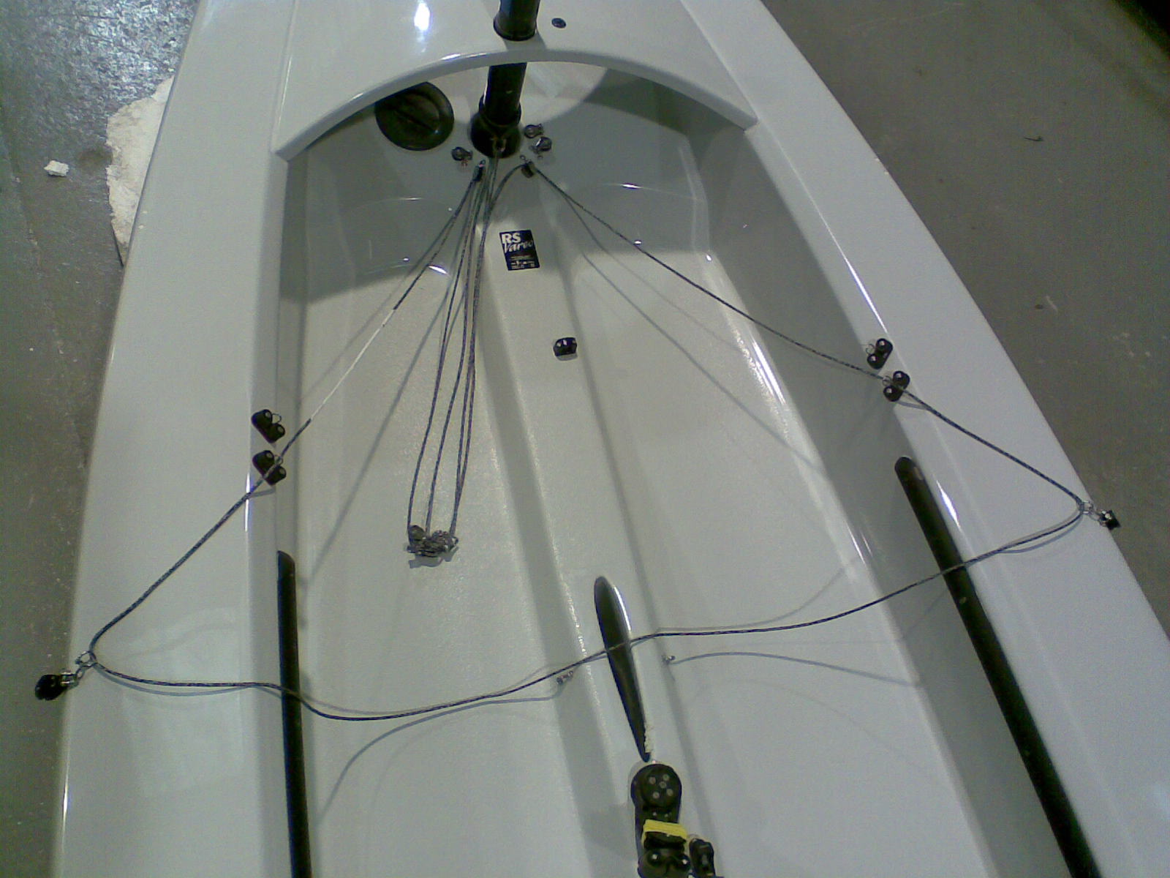

The tricky bit is now joining the two ropes together. This is a link from the association website telling you how to do it:

http://www.rs-association.com/docs/tuning/splicing.jpg

The same file can be found in the file section of the Yahoo user group.

The most fiddly bit is initially pulling the core out. The rest is relatively simple. Some ropes are easier to splice than others depending on how tight their weave is. Ask your rope supplier for their advice on this.

As mentioned before this is one of the simplest methods and what LDC will fit if asked. More complicated versions with shockcord take up are possible. At one point I experimented with the line travelling around the transom like a RS600 but the friction proved prohibitive.

Hope this helps. For advice phone LDC and ask for Junior

